VELAMMAL INSTITUTE OF TECHNOLOGY
Panchetti, Chennai- 601204.
Department of Mechanical Engineering
Question Bank Unit-wise
GE8292-ENGINEERING MECHANICS

UNIT I - PART-A
1.Distinguish the following system of forces with a suitable sketch. a) Coplanar b) Collinear
2.Define Kinetics and Kinematics
3.State Lami’s theorem with a sketch.
4.State parallelogram law and triangle law of forces.
5.What are fundamental and derived units? Give examples
6.Distiguish between units and dimensions. Give examples.
7.Define principle of transmissibility.
8.A force vector F= 700i + 1500j is applied to a bolt. Determine the magnitude of the force and angle it forms with the horizontal
9.A force of magnitude 50 KN is acting along the line joining A(2,0,6) and B(3,-2,0)m. Write the vector form of the force.
10.Two forces of magnitude 50 KN and 80 KN are acting on a particle, such that the angle between the two is 135°. If both the force are acting away from the particle, calculate the resultant and find its direction.
11.A 100N force acts at the origin in a direction defined by the angles θx = 75° and θy = 45°.Determine θz and the component of the force in the Z-direction.
12.Write the equations of equilibrium of a coplanar system of forces.
13.Differentiate between ‘Resultant’ and ‘Equilibrant’
14.Find the resultant of an 800N force acting towards eastern direction and a 500N force acting towards north eastern direction.
15.Find the magnitude of the two forces such that if they act at right angles, their resultant isÖ10 N. But if they act at 60° their resultant is Ö13 N.

UNIT I - PART-B

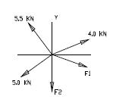
1. The forces shown in the figure below are in equilibrium. Determine the forces F1 and F2

2. Determine the tension in cables AB & AC to hold 40 Kg load shown in fig.
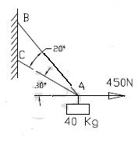

- A force P is applied at ‘O’ to the string AOB as shown in fig. If the tension in each part of string is 50 N, find the direction an magnitude of force P for equilibrium conditions.
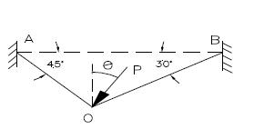

- Two identical rollers each of weight 50N are supported by an inclined plane and a vertical wall as shown in fig. Find the reactions at the points of supports A, B, and C.
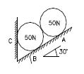

- A tower guy wire shown below is anchored by means of a bolt at A as shown. The tension in the wire is 2500kN.Determine
a) the components Fx,Fy & Fz of the force acting on the bolt b) the angles _x, _y, _z defining the direction of the force.
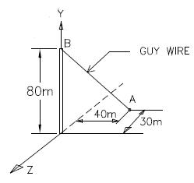

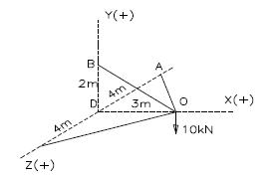
- Members OA, OB and OC form a three member space truss. A weight of 10 KN is suspended at the joint ‘O’ as shown in fig. Determine the magnitude and nature of forces in each of the three members of the truss
- A crane shown in figure is required to lift a load of W=10 KN. Find the forces in the members AB and CB
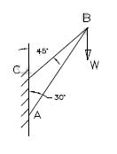

- A precast concrete post weighing 50 Kg and of length 6m shown in fig. is raised for placing it in position by pulling the rope attached to it. Determine the tension in the rope and the reaction at A.
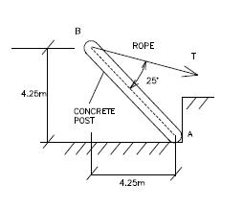

UNIT II - PART-A

- State Varignon’s theorem
- What is a couple? what is a moment of a couple?
- A force vector F has the components Fx = 150N, Fy= -200N and Fx = 300N. Determine the magnitude F and the angle made by the force with coordinate axes.
- Sketch the different types of supports.
- Write down the conditions of equilibrium of a particle in space
- A force vector of magnitude 100N is represented by a line of coordinates A (1, 2, 3) and B (5, 8, 12). Determine components of the force along X, Y and Z axes.
- Explain will you reduce a force into an equivalent force-couple system with an example.
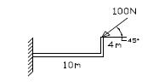
8. Draw Compute the moment of the 100 N force about point A and B

UNIT II - PART-B
- Four forces act on a 700mm X 375mm plate as shown in fig. a) Find the resultant of these forces b) Locate the two points where the line of action of the resultant intersects the edge of the plate.
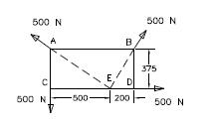

- Four coplanar non concurrent non parallel forces act on a square plate of side 2m as shown in fig. Locate the resultant force.
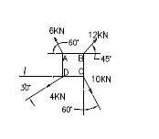

- In figure below, two forces act on a circular disc as shown. If the resultant moment of all these forces about point D on the disc is zero, determine: a) Magnitude of force P (b) Magnitude of the resultant of two forces (c) The point on the Y-axis through which the line of action of the resultant passes through.
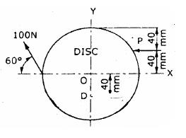

- Four forces act on a square of side 1 m as shown in fig. Reduce the force system into an equivalent force – couple system at A.
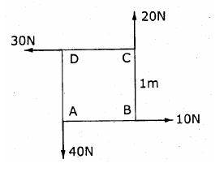

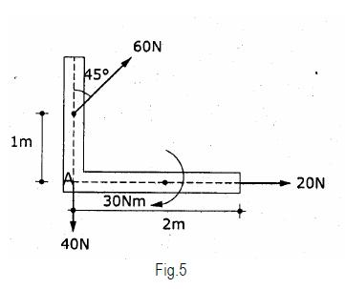
5. Reduce the system of forces shown in fig.5 to a force – couple system at A.

- Blocks A and B of weight 200N and 100N respectively, rest on a 30 inclined plane and are attached to the post which is held perpendicular to the plane by force P, parallel to the plane, as shown in fig. Assume that all surfaces are smooth and that the cords are parallel to the plane. Determine the value of P. Also find the Normal reaction of Blocks A and B.
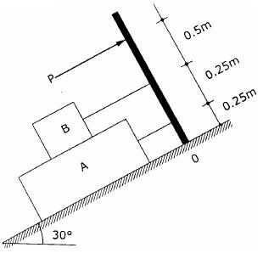

- A Uniform meter rod AB, assumed rigid of mass 0.5 kg is suspended from its ends in an inclined position and a mass of 1 kg is suspended from a point D, as shown in fig. Determine the tension in each string. Where should the suspended mass be placed in order to get equal tension in the strings.
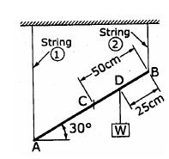

- A rod AB of weight 200 N is supported by a cable BD and the corner of wall and floor surface as shown in fig. Find the reaction at A and tension in the cord.
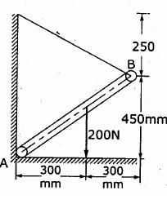

10. Find reactions at points A & B
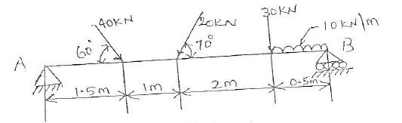

UNIT III - PART-A
1. State parallel axis theorem
2.State perpendicular axis theorem
3.Find the polar moment of inertia of a hollow circular section of external diameter ‘D’ and internal diameter ‘d’
4.Define principal axes and principal moment of inertia
5.Locate the centroid and calculate the moment of inertia about centroidal axes of a semicircular lamina of radius 2m.
6.A semicircular area having a radius of 100 mm is located in the XY-plane such that its diameter coincides with Y-axis.Determine the X-coordinate of the center.
7.Distiguish between centroid and center of gravity.
8.Define polar moment of inertia.
9.Differentiate between ‘Mass moment of inertia’ and ‘Area moment of inertia’
10.Write down the expression for finding mass moment of inertia of a cylinder of radius ‘R’ and height ‘h’ about its base.
UNIT III - PART-B
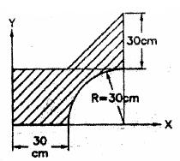
1. Determine the co-ordinates of centroid of the shaded area shown in figure.
- A Cylinder of height of 10 cm and radius of base 4 cm is placed under sphere of radius 4 cm such that they have a common vertical axis. If both of them are made of the same material, locate the centre of gravity of the combined unit.
- Find the moment of inertia of the section shown in the figure about its horizontal centroidal axis.
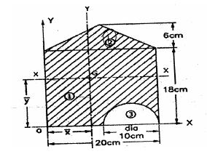

- Calculate the mass moment of inertial of the plate shown in figure with respect to the axis AB. Thickness of the plate is 5 mm and density of the material is 6500 Kg/m3.
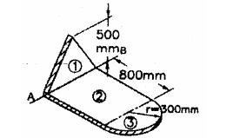

5. Derive expression form mass moment of inertia of prism along three axes.
UNIT IV - PART-A
1. Define D’Alembert’s principle
2.Write down the equations of motion of a particle under gravitation
3.A car accelerates uniformly from a sped of 30 Km/Hr to a speed of 75 Km/Hr in 5 secs. Determine the acceleration of the car and the distance traveled by the car during 5 secs.
4.Explain dynamic equilibrium
5.State the law of conservation of momentum
6.A car starts from rest with a constant acceleration of 4m/sec2. Determine the distance traveled in the 7th second.
7.A point P moves along a straight line according to the equation x= 4t3+2t+5, where x is in meters and t is in secs. Determine the velocity and acceleration at t=3 secs.
8.A stone is projected in space at an angle of 45° to horizontal at an initial velocity of 10 m/sec. Find the range of the projectile.
9.What is work energy principle
10.Write the impulse momentum equation.

UNIT IV - PART-B
- A train is traveling from A to D along the track shown in fig. Its initial velocity at A is zero. The train takes 5 min to cover the distance AB, 2250 m length and 2.5 minutes to cover, the distance BC, 3000 m in length, on reaching the station C, the brakes are applied and the train stops 2250 m beyond, at D (i) Find the retardation on CD, (ii) the time it takes the train to get from A to D, and (iii) its average speed for the whole distance.
- The position of the particle is given by the relation S=1.5t3-9t2-22.5t+60, where S is expressed in meters and t in seconds. Determine (i) the time at which the velocity will be zero (ii) the position and distance traveled by the particle at that time (iii) the acceleration of the particle at that time and (iv) the distance traveled by the particle from t = 5s to t = 7s.
- A particle is projected with a initial velocity of 12m/s at an angle M with the horizontal. After sometime, the position of the particle is observed by its x and y distances of 6m and 4m respectively from the point of projection. Find the angle of projection.
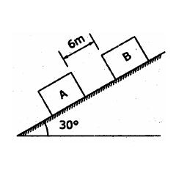
- Two Blocks A and B of weight 100 N and 200 N respectively are initially at rest on a 30° inclined plane as shown in figure. The distance between the blocks is 6 m. The co efficient of friction between the block A and the plane is 0.25 and that between the block B and the plane is 0.15. If they are released at the same time, in what time the upper block (B) reaches the Block (A).

- Two blocks of weight 150 N and 50 N are connected by a string and passing over a frictionless pulley as shown in figure. Determine the acceleration of blocks A and B and the
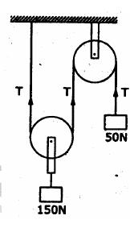
tension in the string.

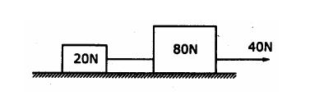
- Two weights 80 N and 20 N are connected by a thread and move along a rought horizontal plane under the action of a force 40 N, applied to the first weight of 80 N as shown in figure. The coefficient of friction between the sliding surfaces of the wrights and the plane is 0.3. Determine the acceleration of the weights and the tension in the thread using work-energy equation.

- Two blocks of weight 150N and 50N are connected by a string, passing over a frictionless pulley as shown in fig. Determine the velocity of 150N block after 4 seconds. Also calculate the tension in the string.
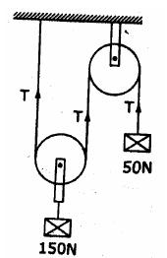

- Two bodies, one of mass 30kg, moves with a velocity of 9m/s centrally. Find the velocity of each body after impact, if the coefficient of restitution is 0.8.
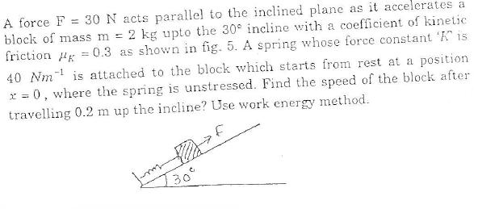

UNIT V - PART-A
1.Give mathematical definitions of velocity and acceleration.
2.A Car traverses half of a distance with a velocity of 40 Kmph and the remaining half of distance with a velocity of 60 Kmph. Find the average velocity.
3.Define friction and classify its types.
4.Classify the types of friction.
5.Define Limiting friction.
6.Define coefficient of static friction.
7.Stat coulomb’s laws of dry friction.
8.Define rolling resistance.
9.What is coefficient of rolling resistance?
10.Define coefficient of friction and express its relationship with angle of friction.
11.If x=3.5t3– 7 t2, determine acceleration, velocity and position of the particle, when t = 5 sec.
12.Consider a wheel rolling on a straight track. Illustrate the characteristics of general plane motion.
13.Write work energy equation of rigid body. Mention the meaning for all parameters used in the equation.
14.What us general plane motion? Give some examples.
15.Define Limiting friction.
16.Define Co-efficient of friction and angle of friction
17.Define coulomb’s laws of dry friction.
18.Define impending motion.

19.Define angle of repose
20.Define cone of friction.
21.Define the following terms i) Ladder friction. ii) Wedge friction iii) Screw friction iv) Belt friction.

UNIT V - PART-B
- Block (2) rests on block (1) and is attached by a horizontal rope AB to the wall as shown in fig. What force P is necessary to cause motion of block (1) to impend? The co-efficient of friction between the blocks is ¼ and between the floor and block (1) is 1/3. Mass of blocks
(1)and(2) are 14kg and 9 kg respectively
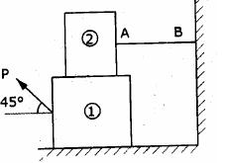

- Block A weighing 1000 N rests on a rough inclined plane whose inclination to the horizontal is 45°. It is connected to another block B, weighing 3000 N rests on a rough horizontal plane by a weightless rigid bar inclined at an angle of 30° to the horizontal as shown in fig. Find the horizontal force required to be applied to the block B just to move the block A in upward direction. Assume angle of friction as 15° at all surfaces where there is sliding.
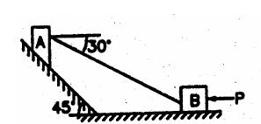

- A 7m long ladder rests against a vertical wall, with which it makes an angle of 45° and on a floor. If a man whose weight is one half that of the ladder climbs it, at what distance along the ladder will he be, when the ladder is about to slip? Take coefficient of friction between the ladder and the wall is 1/3 and that between the ladder and the floor is ½.
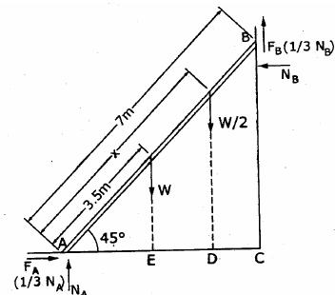

- In a screw jack, the pitch of the square threaded screw is 5.5 mm and means diameter is 70 mm. The force exerted in turning the screw is applied at the end of lever 210 mm long measured from the axis of the screw. If the co-efficient of friction of the screw jack is 0.07. Calculate the force required at the end of the lever to (i) raise a weight of 30 KN (ii) lower the same weight.

- An effort of 200 N is required just to move a certain body up an inclined plane of angle 15°, the force is acting parallel to the plane. If the angle of inclination of the plane is made 20°, the effort required being again parallel to the plane, is found to be 230 N. Find the weight of the body and coefficient of friction.

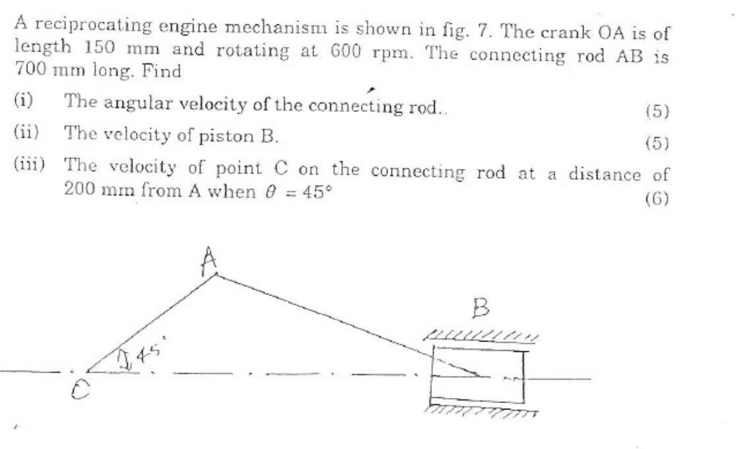
- Find the force P inclined at an angle of 32° to the inclined plane making an angle of 25 degree with the horizontal plane to slide a block weighing 125 KN (i) up the inclined plane (ii) Down the inclined plane, when P = 0.5

